

PNEUMATIC
ELECTRO-PNEUMATIC STANDARD TRAINER

CONTENTS

Page 1-4 | Subject Area  Features  Machine Specification
Page 5 | Machine
Page 6 | Training

PNEUMATIC/ELECTRO-PNEUMATIC STANDARD TRAINER

Subject Area: Trainer plus additional components that add an extra degree of complexity to the Electro Pneumatic Circuit.

Features: Push-fit connections, comprehensive curriculum, wide range of assignments. Interface of PLC in operations. Modular frame with cabinet.

PNEUMATIC PARTS | SPECIFICATION
3/2 WAY MANUAL VALVE | - Pushbutton Valve Pressure Range: 0.2~0.7 MPA.  - Proof pressure 1.5Mpa  - Number of port 3  - Number of position 2
4/3 WAY MANUAL VALVE | - Selector Switch Valve Pressure Range: 0.2~0.7 MPA.  - Number of port 5  - Number of Position 2
ROLLER VALVE | - Mechanical Valve Pressure Range: 0.2~0.7 MPA.  - Proof pressure 1 Mpa  - Number Port 3  - Number of Position 2
THROTTLE VALVE | - Port Flow Control  - Pressure Range:0~1 MPA.
5/2 WAY AIR PILOTED VALVE | - Air Pilot Valve Pressure Range: 0.2~0.7 MPA.  - Proof pressure 1.5 Mpa  - Number port 5  - Number of position 2
5/2 WAY DUAL AIR PILOTED VALVE | - Air Pilot Valve Pressure Range: 0.2~0.7 Mpa  - Number of port 5  - Number of Position 3
AND VALVE | - Gate Valve Pressure Range: 0.2~0.7 MPA.  - Proof pressure 1.5 Mpa

PNEUMATIC/ELECTRO-PNEUMATIC STANDARD TRAINER

Subject Area: Trainer plus additional components that add an extra degree of complexity to the Electro Pneumatic Circuit.

Features: Push-fit connections, comprehensive curriculum, wide range of assignments. Interface of PLC in operations. Modular frame with cabinet.

PNEUMATIC PARTS | SPECIFICATION
OR VALVE | - Gate Valve Pressure Range: 0.2~0.7 MPA.  - Proof pressure 1.5 Mpa
SINGLE ACTING CYLINDER | - Spring Return Cylinder  - Max operating pressure 1 Mpa  - Min operating pressure 0.05 Mpa
DOUBLE ACTING CYLINDER | - Acting type double acting  - Max Operating pressure 1 Mpa  - Min operating pressure 0.05 Mpa
GRIPPER CYLINDER | - Parallel Griper Pressure Range: 0.2~0.7 MPA.
AIR DISTRIBUTOR MANIFOLD | - Port Manifold with Check Valve  - Rotary Joint Fittings
PRESSURE GAUGE | - Pressure Range 0-8 Bars  - Proof pressure the max. Scale of gauge times 1.2
SERVICE UNIT FRL | - Operating pressure range 0.05~1 MPa  - Proof pressure 1.5 Mpa  - Regulated pressure range 0.05~0.85 Mpa  - Filter element standard: 40µm Option: 5µm  - Lubricating oil capacity 35c.c
AIR COMPRESSOR | - Power: 1.0HP  - Voltage: 220V  - Frequency: 60Hz  - Rated Revolving Speed: 1700R/min  - Cylinder: 63.7MM*2

PNEUMATIC/ELECTRO-PNEUMATIC STANDARD TRAINER

Subject Area: Trainer plus additional components that add an extra degree of complexity to the Electro Pneumatic Circuit.

Features: Push-fit connections, comprehensive curriculum, wide range of assignments. Interface of PLC in operations. Modular frame with cabinet.

PNEUMATIC PARTS | SPECIFICATION
3/2 WAY SOLENOID VALVE | - Electrically operated 24VDC Valve  - Power consumption DC=2W  - Proof pressure 1.5 Mpa  - Number of port 3  - Number of Position 2
5/2 WAY SINGLE SOLENOID VALVE | - Electrically operated 24VDC Valve  - Power consumption DC=2W  - Number of port 5  - Number of Position 2
5/2 WAY DOUBLE SOLENOID VALVE | - Electrically operated 24VDC Valve  - Power consumption DC=2W  - Number of port 5  - Number of Position 3
POWER SUPPLY MODULE | - 220VAC Power Input  - 24VDC 6 Ampere  - Output Voltage Adj. Range: ± 10%  - Banana Socket Connection
PUSHBUTTON MODULE | - Colors RED/GREEN  - Actuation Momentary/Non-Momentary  - Banana Socket Connection  - Acrylic Frame Board
PILOT LIGHT MODULE | - Colors RED/GREEN  - Voltage Rating 24VDC  - Lamp Type LED  - Banana Socket Connection  - Acrylic Frame Board

PNEUMATIC/ELECTRO-PNEUMATIC STANDARD TRAINER

Subject Area: Trainer plus additional components that add an extra degree of complexity to the Electro Pneumatic Circuit.

Features: Push-fit connections, comprehensive curriculum, wide range of assignments. Interface of PLC in Operations. Modular Frame with cabinet.

PNEUMATIC PARTS | SPECIFICATION
RELAY MODULE | - Coil Voltage 24VDC  - Contact Configuration 4PDT  - Banana Socket Connection  - Acrylic Frame Board
LIMIT SWITCH MODULE | - Actuator Type Roller Lever  - Pole and Throw Configuration SPDT  - Banana Socket Connection  - Acrylic Frame Board
TIMER/COUNTER MODULE | - Input Power 24VDC  - Control Settings Range 0.05 SEC TO 1 HR  - Contact Type DPDT  - Contact Capacity 5 Amp  - Counter Counts per Second 10,000  - Banana Socket Connection
PROGRAMMABLE LOGIC CONTROLLER | - 8 DI 24V DC; 6 DO Relay 2 A; 2 Al 0-10V DC, Power Supply: DC 20.4 – 28.8 V DC, MPU points: 14 (8DI+6DO) Max. I/O points; 494 (14+480) Program capacity: 8k steps COM port: Built-in RS-232 & RS-485 ports, compatible with Modbus ASCII/RTU protocol. Can Be master or salve. High-Speed Pulse Output: Supports 4 points (Y0 ~ Y3) of independent high-speed max.
OPERATION MANUAL
WORKING TABLE

PNEUMATIC/ELECTRO-PNEUMATIC STANDARD TRAINER

MACHINE

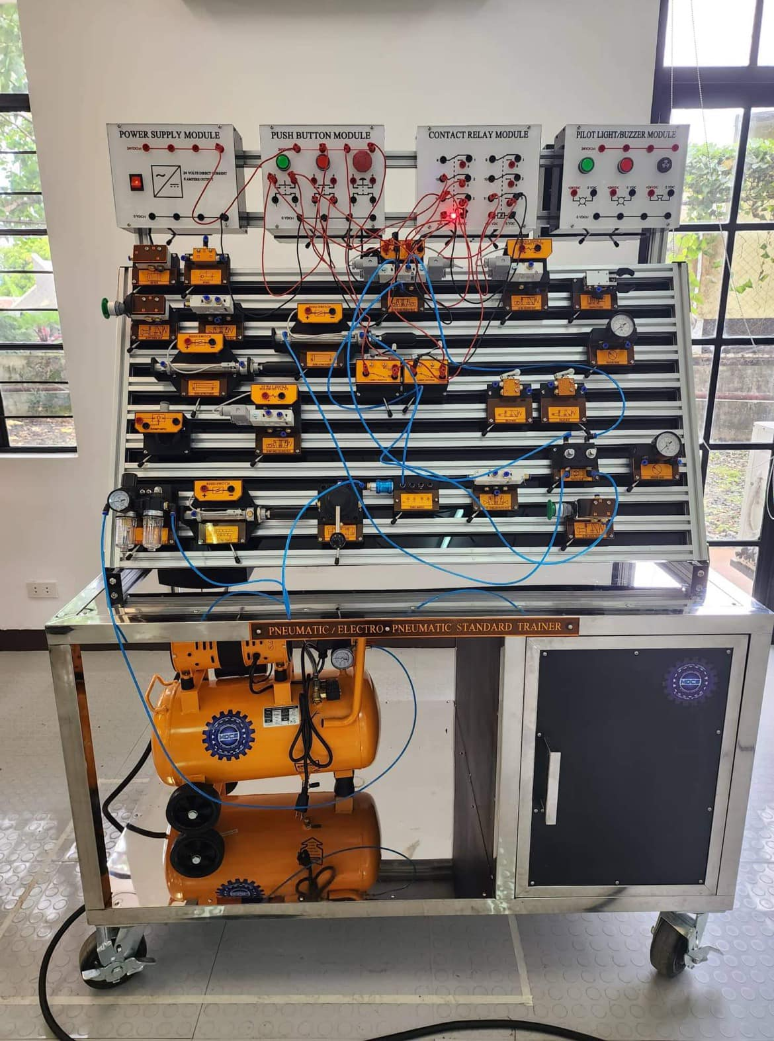
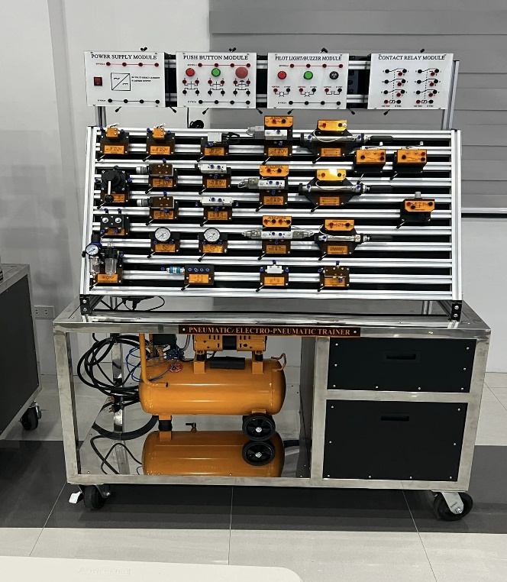

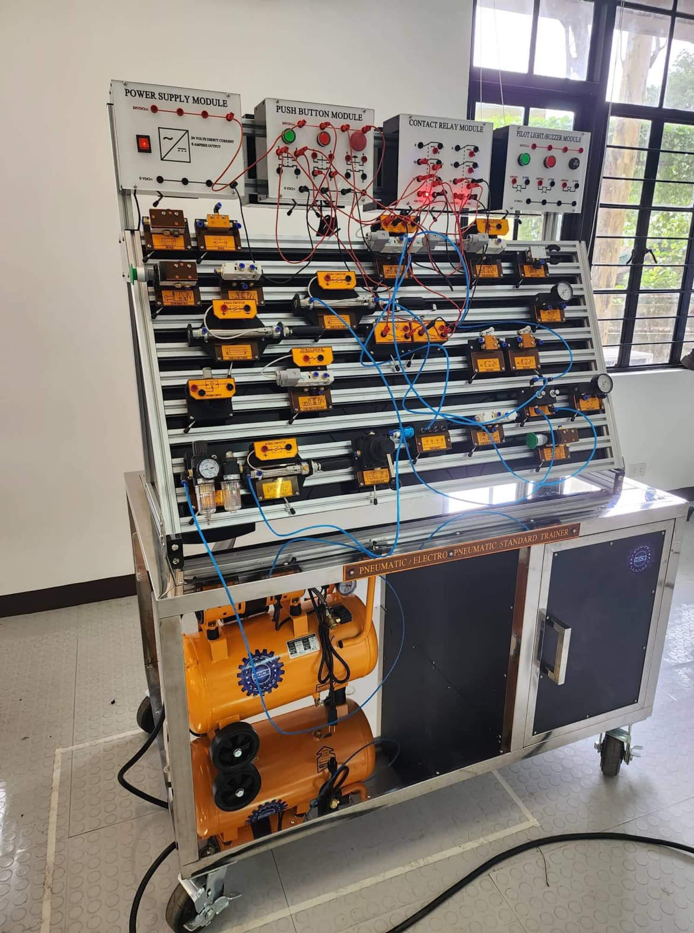
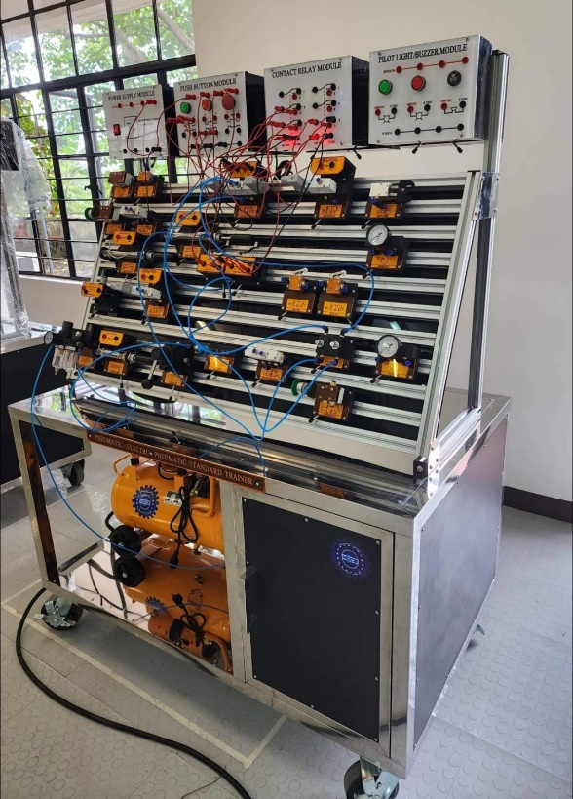

PNEUMATIC/ELECTRO-PNEUMATIC STANDARD TRAINER

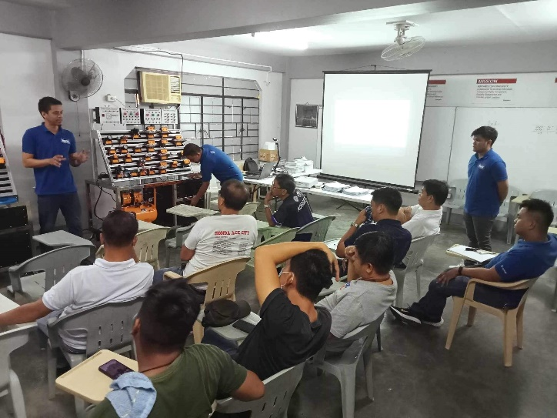
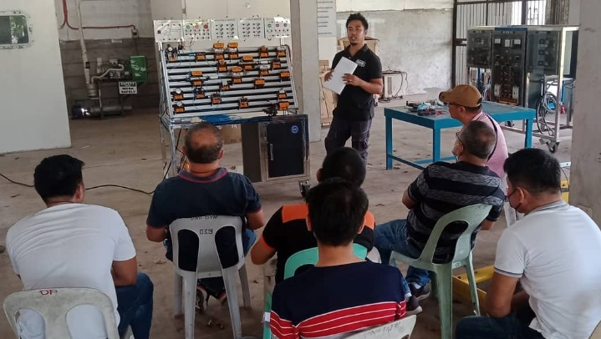
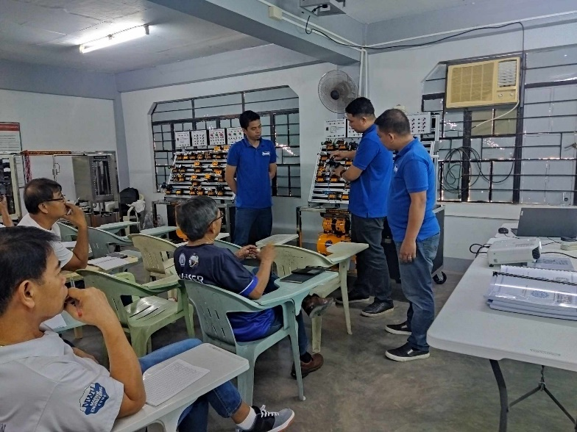
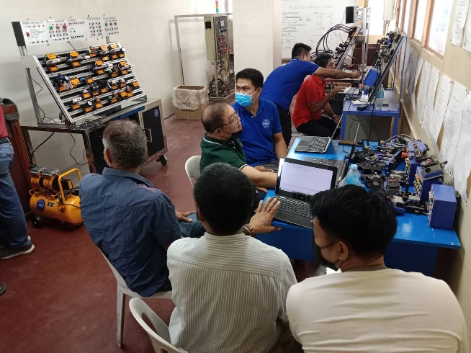
TRAINING

